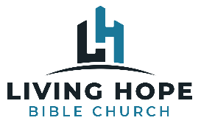
Life Group Discussion Guide
Matthew: The King and His Kingdom
Jesus the Botanist

April 3, 2022

Intro:

1. Do you like fruit? Why or why not? What is your favorite fruit?

2. Why does it hurt and cause so much damage when a pastor is a “bad apple?”

Discussion: Read Matthew 7:15-20

1. True teachers and false teachers both appeal to the Bible. How do we spot the difference?

2. What are the marks of false teachers?

3. Jesus is not commanding “Heresy Hunting” where we are on hunt to find and label someone as a false teacher because they disagree with a minute sliver of theology with us, but we should confront false teaching. How would someone humbly and productively do this?

4. Can someone teach something incorrect and not be a false teacher?

5. Can someone teach correct theology and be a false teacher?

6. What is “good fruit” in the context of Jesus’ Sermon? (vs13-14, 21-23).

7. What do many of Christian’s call “good fruit” that is based more on business and the marketplace than on Jesus’ teaching?

8. Do you think congregants in church and their expectations for leaders and pastors create an environment for those leaders and pastors to fail?

9. Ryan used an illustration about “Christmas Tree Christians” what did that mean?

10. Can we manufacture our own fruit? If so, how? If not, how can we produce good fruit?

11. What is the core of the Christian faith? The gift of salvation that God gives us is a means to an end. What is that end?

12. How can you deepen your roots in your life with God?

