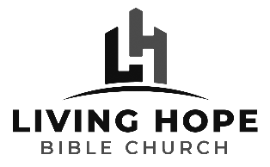
Life Group Discussion Guide
Matthew: The King and His Kingdom
Two Paths – One True Way

March 27, 2022

Read Matthew 7:12-14

Big Idea: The Choices You Make Today Will Affect Your Life Tomorrow (and beyond), so Choose Wisely!

1. How can we enter the kingdom of heaven?

2. What are characteristics of the wide pathway?

3. What are characteristics of the narrow pathway?

4. What is a time when you were a recipient of someone living out the “Golden Rule”? How did it impact you?

5. Is there someone whom you hesitate to demonstrate the Golden Rule? Who? Why do you think it is so difficult to treat that particular person the way you would like to be treated?

6. How have you heard people react to Jesus’ statement that there is only one true gate, road, and destination?

7. Who of your loved ones is on the “broad path” that leads to destruction? How does this impact your embrace of Jesus’ teaching that the only way to life is through faith in Him?

8. Read Luke 13:22-30. What is the question that is asked of Jesus and how does He answer? In vs24, how might someone seek to enter the narrow gate and not be able to?

9. Read John 3:36, Acts 4:12, I Timothy 2:5. How narrow is the gate Jesus mentions?

10. How could you ask God to change your thinking about a person that you have a difficult time applying the Golden Rule to in order to make it easier for you to treat him or her better?

11. A God given warning is always an act of grace. In what way is the truth of the narrow gate a grace to you? Others?

12. Read Romans 1:18-23 and discuss.

