Growth Group Bible Study
Faith that Works - Series
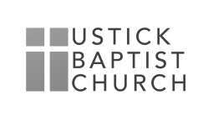
Faith that Works in Making Plans

November 15, 2020

Reading James 4:13-17

Read James chapter 4:13-14 and Answer the Following Questions:

- What warning did James give to those who make plans for the future?

- What could happen to destroy even the best laid plans?

- What is a person saying about God and self when he makes plans without consulting God?

Read James 4:15-16

- What is the best way to plan ahead?

- How can we make plans for business or living which are pleasing to God?

- Why do Christians sometimes boast, brag, and make plans for their lives and work but give no thought of God’s plan?

Read James 4:17

- How did James define sin?

- How do we sin?

- How can you determine in your daily life what is sinful and what is pleasing to God?

- What plans for the future are you living by? Evaluate them in light of 4:11-17

