Growth Group Bible Study
Faith that Works - Series
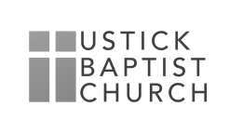
Faith that Works Through Words

October 25, 2020

Reading James 3:1-12

Read James chapter 3:1-4 and Answer the Following Questions:

- What unique responsibility does a teacher bear? In what way will teachers be judged more strictly?

- Why is it so difficult for us at times to say the right thing instead of the wrong thing?

- Why isn’t the tongue problem solved when people become Christians? In what ways do you struggle with the tension between “the old man” and “the new man?”

Read James Chapter 3:5-8

- How can a person be hurt by the words of others?

- What practical advice would you give someone who wanted to control his or her tongue better?

Read James Chapter 3:9-10

- What are the ways we sin with our speech?

- What would you say to someone who professed faith in Christ but was either unwilling or seemingly unable to control their tongue?

- What kind of damage does an uncontrolled tongue do to a family? Marriage? Children? Church?

Read James 3:11-12

- What weaknesses in our lives does our speech often expose?

- How can we submit our tongues to the control of the Holy Spirit? What would be the result?

